**Ideation Phase**

**Define the Problem Statement**

|  |  |
| --- | --- |
| Date | 19 September 2022 |
| Team ID | PNT2022TMID04876 |
| Project Name | Project – IOT based Real-Time River Water Quality Monitoring and Control System |
| Maximum Marks | 2 Marks |

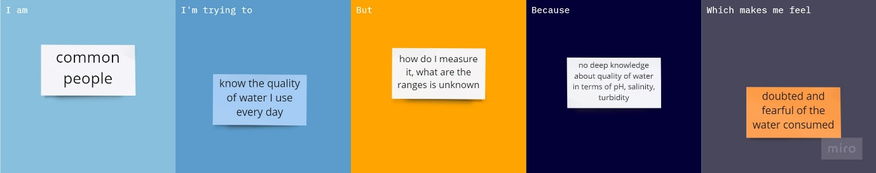

|  |  |  |
| --- | --- | --- |
| I am | Common people living a normal life on Earth | Common people living on Earth who consume water in their day-to-day life for different purpose |
| I’m trying to | Monitor the quality of the water | Wants to monitor the water consumed everyday whether the water is contaminated or pure, pH, temperature, salinity in it |
| but | Do not know to monitor the quality of water | Time consuming process for manual testing |
| because | Lack of required knowledge | Common people lack knowledge of this type of testing, sensors etc. |
| Which makes me feel | Doubted and fearful of the consumed water | Decline of pure water, increasing viral diseases |